2.Draw a coffe coffe day ordering system. A coffe coffee day shop vending machine
dispenses coffee to customers. Customers order coffee by selecting a recipe from a set
of recipes. Customers pay for the coffee using coins. Change is given back, if any, to
the customers. The ‘service assistant’ loads ingredients (coffee powder, milk, sugar,
water, chocolate) into the coffee machine. The ‘service assistant’ adds recipe by
indicating the name of the coffee, the units of coffee powder, milk, sugar, water,
chocolate to be added as well as the cost of the coffee. The service assistant can also
edit and delete a recipe. Develop the use case diagram for the specification above.

AIM: To design a UML diagram for a coffee vending machine system, illustrating interactions between customers and service assistants.

PROCEDURE:

Identify Actors:
- Customer: Orders and pays for coffee.
- Vending Machine: Prepares and dispenses coffee.
- Service Assistant: Maintains ingredients and recipes.
Define Use Cases:
- Select coffee recipe.
- Make payment.
- Dispense coffee.
- Load ingredients into the machine.
- Add, edit, or delete coffee recipes.
Create Diagrams:
- Use Case Diagram: Shows how customers interact with the vending machine.

DIAGRAM:

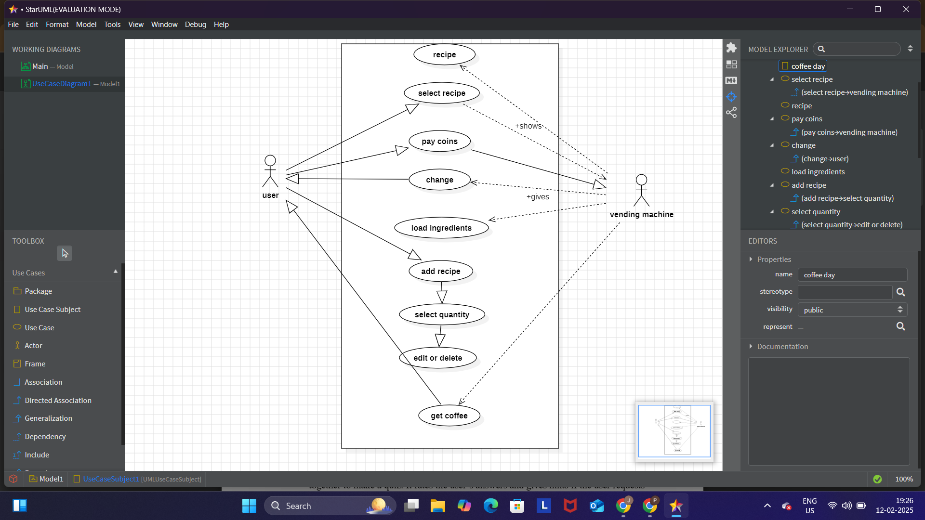

RESULT :

The UML diagrams provide a clear overview of the coffee ordering system, ensuring better understanding and system design.

